RESOLUTION NO.__________

RE: CERTIFICATE OF APPROPRIATENESS UNDER THE
PROVISIONS OF THE ACT OF THE PENNSYLVANIA
LEGISLATURE 1961, JUNE 13, P.L. 282 (53
SECTION 8004) AND BETHLEHEM ORDINANCE NO.
3952 AS AMENDED.

WHEREAS, it is proposed to re-roof the house at 238 E. Wall St. and install two new skylights on the rear roof.

NOW, THEREFORE, BE IT RESOLVED by the Council of the City of Bethlehem that a Certificate of Appropriateness is hereby granted for the proposal.

Sponsored by: (s)

(s)

ADOPTED BY COUNCIL THIS DAY OF

(s)
President of Council

ATTEST:

(s)
City Clerk

HISTORICAL & ARCHITECTURAL REVIEW BOARD

The applicant is proposing to re-roof the house at 238 Wall St. and install two new skylights on the rear roof.
APPLICATION #1:

Patrick & Hannah Conroy
238 E. Wall St.
Bethlehem, PA 18018

518 Main St.
Bethlehem, PA 18018

OWNER:

__________________________________________________________________________

The Board upon motion by Phil Roeder and seconded by Diana Hodgson adopted the proposal that City Council issue a Certificate of Appropriateness for the following:

- Re-roofing with exposed valley and chimney flashings copper or lead coated copper.

2. White metal roof edges.

3. Hatteras shingles in slate gray color.

4. Install two new Velux skylights in bronze colored finish.

5. Roofing to include shingle covered full width ridge vent.

6. The motion was unanimously approved.

__________________________________________________________________________

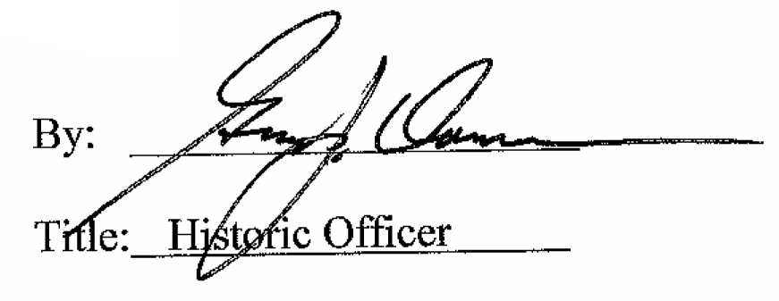

Date of Meeting: November 1, 2017

